**Random Forest Classification**

**Confusion Matrix:**

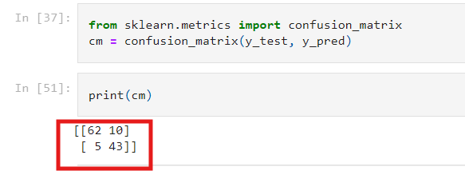

**Purchased**

Confusion Matrix for Purchased **True** is 62

Confusion Matrix for Purchased **False** is 10

**Not Purchased:**

Confusion Matrix for Not Purchased **True** is 43

Confusion Matrix for Not Purchased **False** is 5

**Classification Report:**

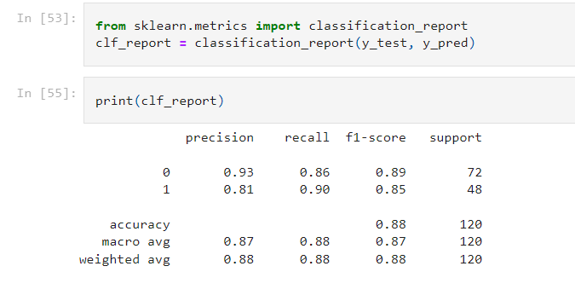

**Accuracy:**

What is the Accuracy of the Model?

0.88%

**Explanation:**

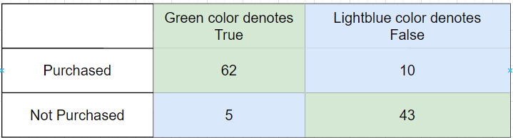

**Formula:**

**T(Purchased) + T(Not-Purchased)**

**--------------------------------------------**

**T(Purchased) + T(Not-Purchased) + F(Purchased) + F(Not-Purchased)**

**62 + 43 105**

**------------------------------- = --------------------------- = 0.88%**

**62 + 43 + 10 + 5 120**

**Precision:**





**Total Count in the test set = 120**

**Total Count of Purchased in the test set = 72**

**Total Count of Not Purchased in the test set = 48**

**Questions:**

What is the percentage of correct classification of Purchased to sum of correctly classified as Purchased and wrongly classified as Not-purchased in the test set.

**Formula:**

**T(Purchased)**

**------------------**

**T(Purchased) + F (Not Purchased)**

**62 62**

**--- = --- = 0.93%**

**62 + 5 67**

**Questions:**

What is the percentage of correct classification of Not-Purchased to sum of correctly classified as Purchased and wrongly classified as Purchased in the test set.

**Formula:**

**T(Not-Purchased)**

**------------------**

**T(Not-Purchased) + F (Purchased)**

**43 43**

**--- = --- = 0.81%**

**43 + 10 53**

**Recall:**





**Total Count in the test set = 120**

**Total Count of Purchased in the test set = 72**

**Total Count of Not Purchased in the test set = 48**

**Questions:**

What is the percentage of correct classification of Purchased to the total input of Purchased in the test set

**Formula:**

**T(Purchased)**

**------------------**

**Total count of (Purchased) in the test set**

**62**

**--- = 0.86%**

**72**

**Questions:**

What is the percentage of correct classification of Not-Purchased to the total input of Not-Purchased in the test set

**Formula:**

**T(Not-Purchased)**

**------------------**

**Total count of (Not-Purchased) in the test set**

**43**

**--- = 0.90%**

**48**

**F1-score:**





**Formula:**

**Recall (Purchased) * precision (Purchased)**

**2 * ------------------------**

**Recall (Purchased) + precision (Purchased)**

**0.86 * 0.93 0.80**

**2 * -------------- = 2 * --------- = 0.89%**

**0.86 + 0.93 1.79**

**Formula:**

**Recall (Not-Purchased) * precision (Not-Purchased)**

**2 * ------------------------**

**Recall (Not-Purchased) + precision (Not-Purchased)**

**0.90 * 0.81 0.80**

**2 * -------------- = 2 * --------- = 0.85%**

**0.90 + 0.81 1.85**

**Questions:**

What is the overall performance for Purchase: **0.89%**

What is the overall Not-performance for Purchase: **0.85%**

**Macro avg:**





**Formula:**

**Precision (Purchased) + Precision (Not-Purchased**

**------------------------------------------------------------------**

**2**

**0.93 + 0.81 1.74**

**-------------- = ------ = 0.87%**

**2 2**

**Recall (Purchased) + Recall (Not-Purchased**

**------------------------------------------------------------------**

**2**

**0.86 + 0.90 1.76**

**-------------- = ------ = 0.88%**

**2 2**

**F1-score (Purchased) + F1-score (Not-Purchased**

**------------------------------------------------------------------**

**2**

**0.89 + 0.85 1.74**

**-------------- = ------ = 0.87%**

**2 2**

**Questions:**

**What is the average performance (correctly & wrongly classified) precision = 0.87%**

**What is the average performance (correctly & wrongly classified) recall = 0.88%**

**What is the average performance (correctly & wrongly classified) f1-score = 0.87%**

**Weighted avg:**



**Formula:**

**Total Count in the test set = 120**

**Total Count of Purchased in the test set = 72**

**Total Count of Not Purchased in the test set = 48**

**Precision (Purchased) * (Total count of purchased/ total count) + Precision (Not-Purchased) * (Total count of not-purchased/ total count) +**

**0.93 * (72/120) + 0.81 * (48/120)**

**0.93 * 0.6 + 0.81 * 0.4**

**0.88%**

**Formula-Recall:**

**Total Count in the test set = 120**

**Total Count of Purchased in the test set = 72**

**Total Count of Not Purchased in the test set = 48**

**recall (Purchased) * (Total count of purchased/ total count) + recall (Not-Purchased) * (Total count of not-purchased/ total count) +**

**0.86 * (72/120) + 0.90 * (48/120)**

**0.93 * 0.6 + 0.81 * 0.4**

**0.88%**

**Formula-F1-Score:**

**Total Count in the test set = 120**

**Total Count of Purchased in the test set = 72**

**Total Count of Not Purchased in the test set = 48**

**F1Score (Purchased) * (Total count of purchased/ total count) + F1Score (Not-Purchased) * (Total count of not-purchased/ total count) +**

**0.89 * (72/120) + 0.85 * (48/120)**

**0.93 * 0.6 + 0.81 * 0.4**

**0.88%**

**Questions**

What is the sum of precision rate (weight) of each class= 0.88%

What is the sum of recall rate (weight) of each class= 0.88%

What is the sum of f1-score rate (weight) of each class= 0.88%